- SUSHRUTH(192411073)
1.Write a program to Print Fibonacci Series using recursion.
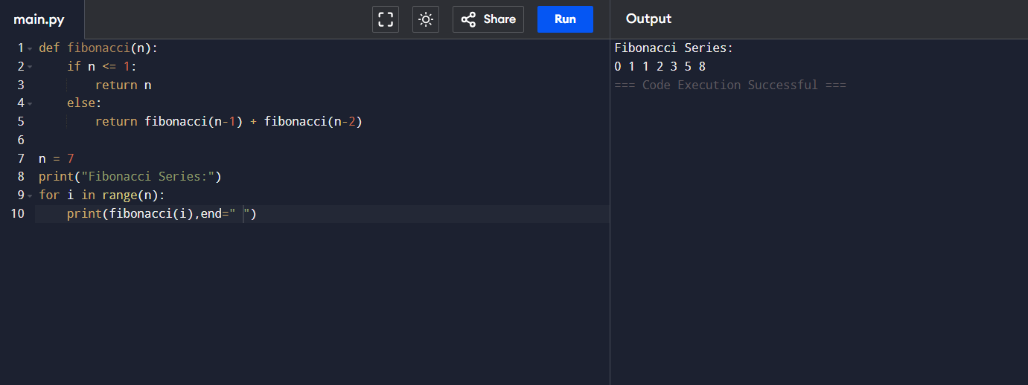
2.Write a program to check the given no is Armstrong or not.
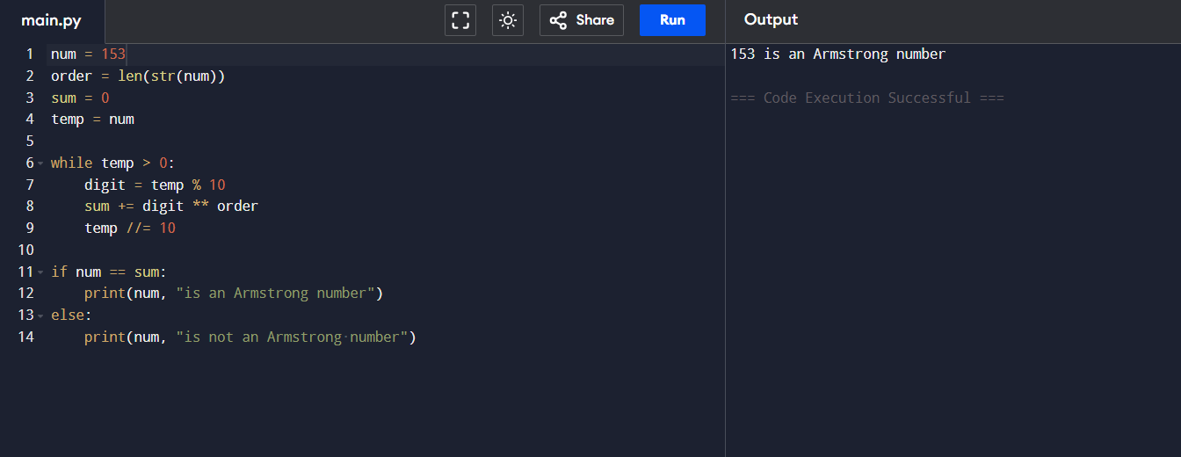 3.Write a program to find the GCD of two numbers .
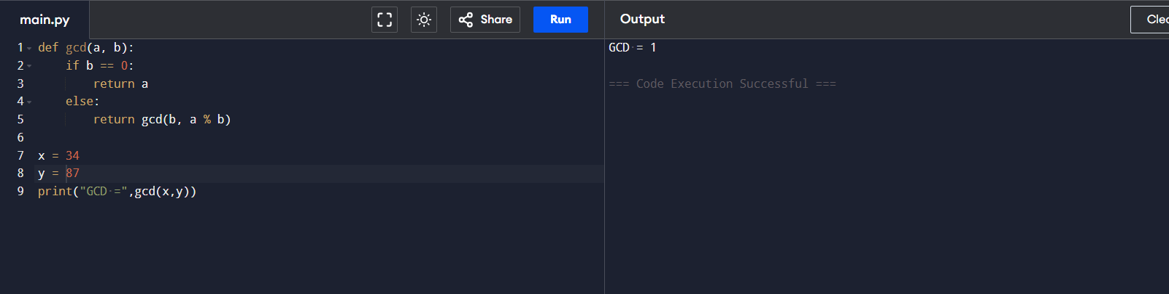
4. Write a program to get the largest element of an array.
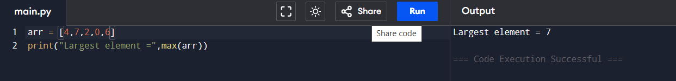
5. Write a program to find the Factorial of a number . 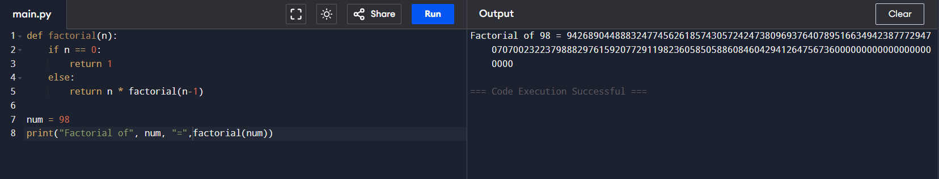
6.Write a program to check a number is a prime number or not .
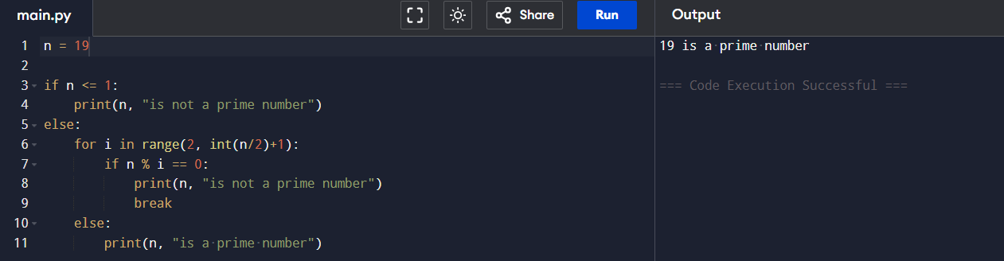
7.Write a program to perform Selection sort.
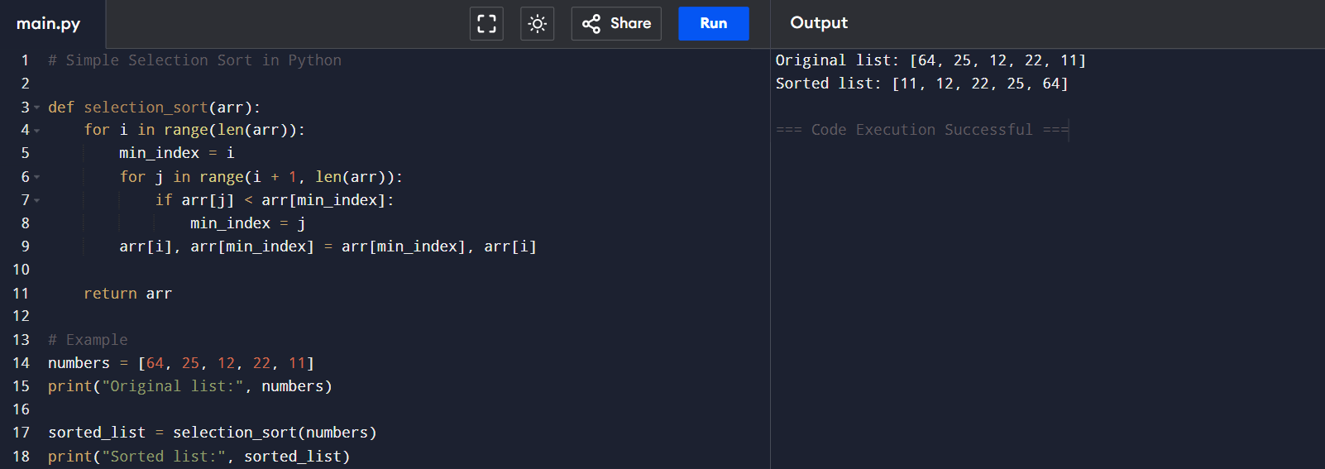
8.Write a program to perform Bubble sort
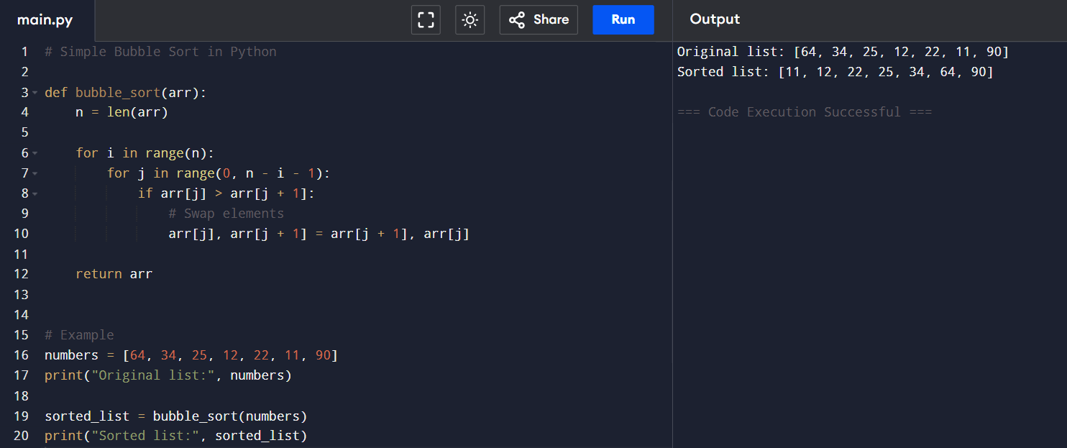
9.Write a program for to multiply two Matrix
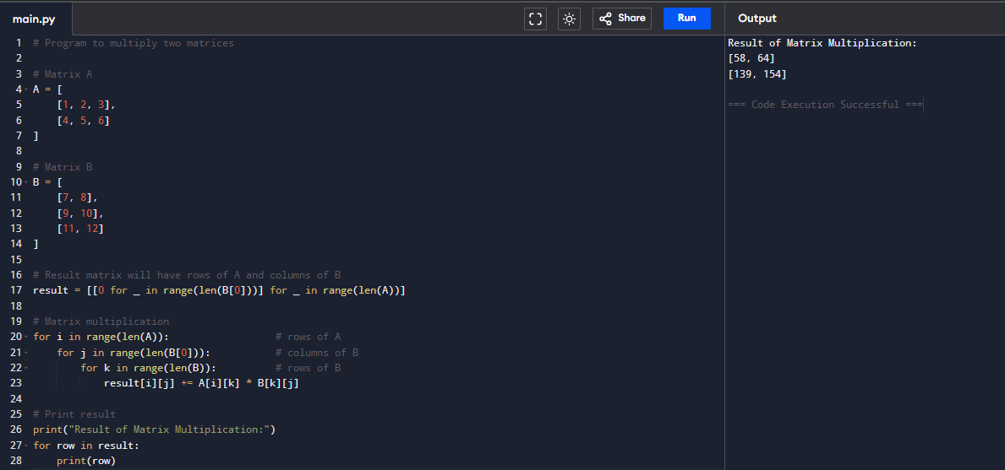
10.Write a program for to check whether a given String is Palindrome or not
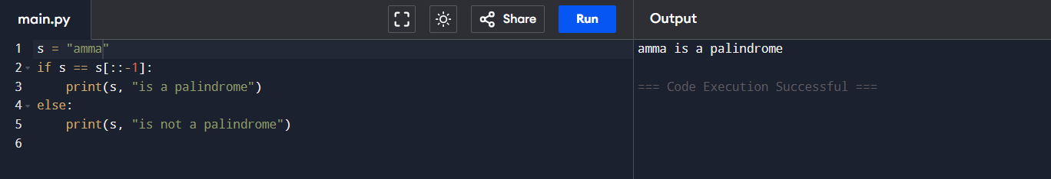
11.Write a program for to copy one string to another
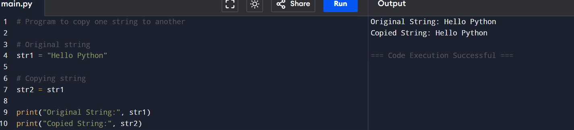

12. Write a Program to perform binary search.
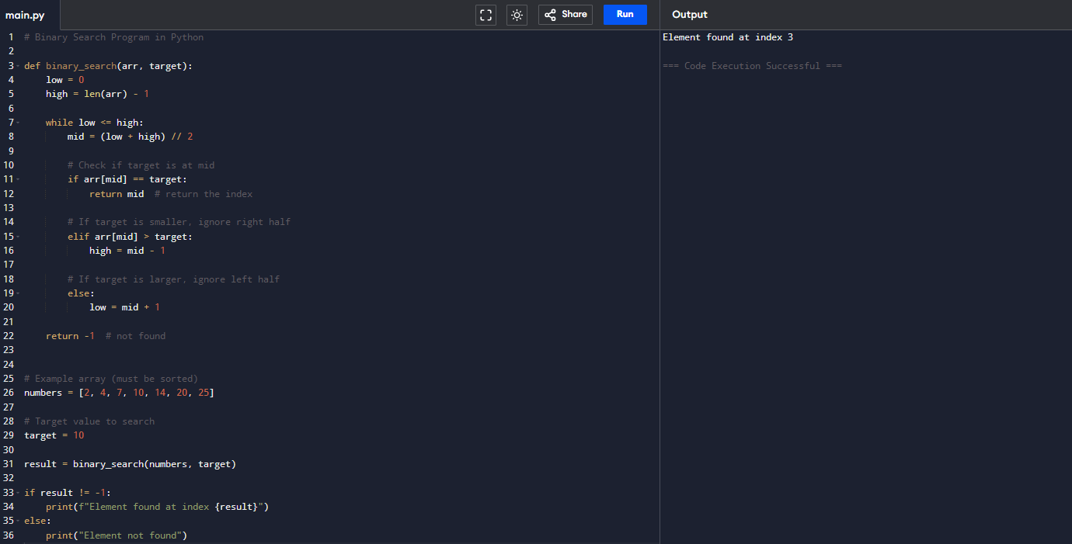
13.Write a program to print the reverse of a string
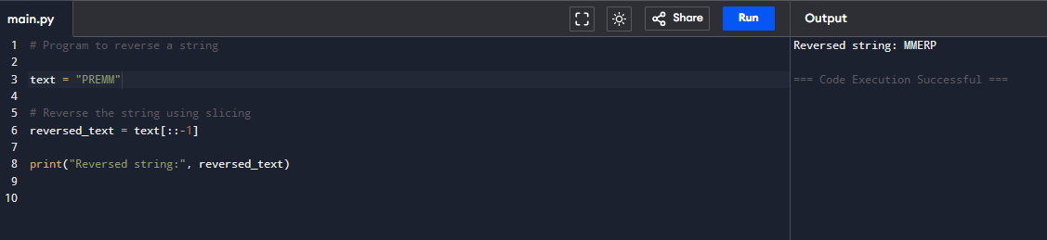
14. Write a program to find the length of a string.
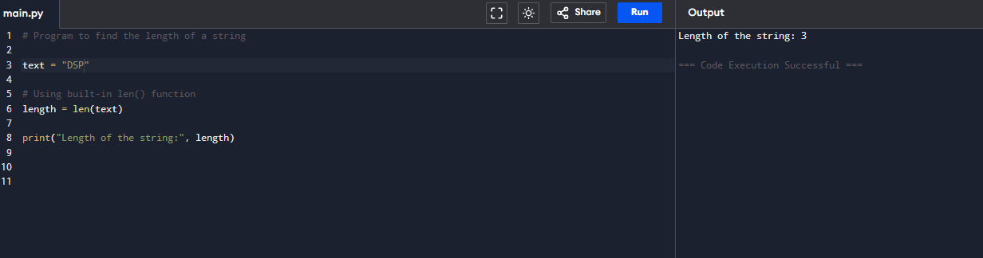

15. Write a program to perform Strassen’s Matrix Multiplication.
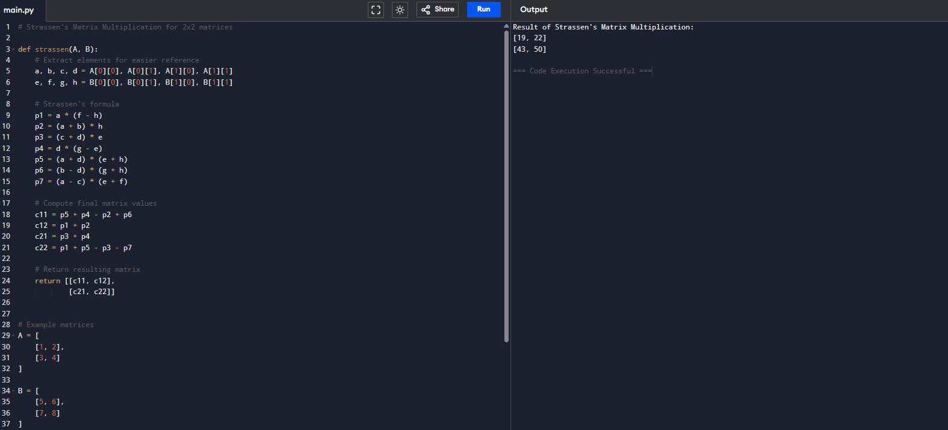
16.Write a program to perform Merge Sort.

17.Using Divide and Conquer strategy to find Max and Min value in the list.
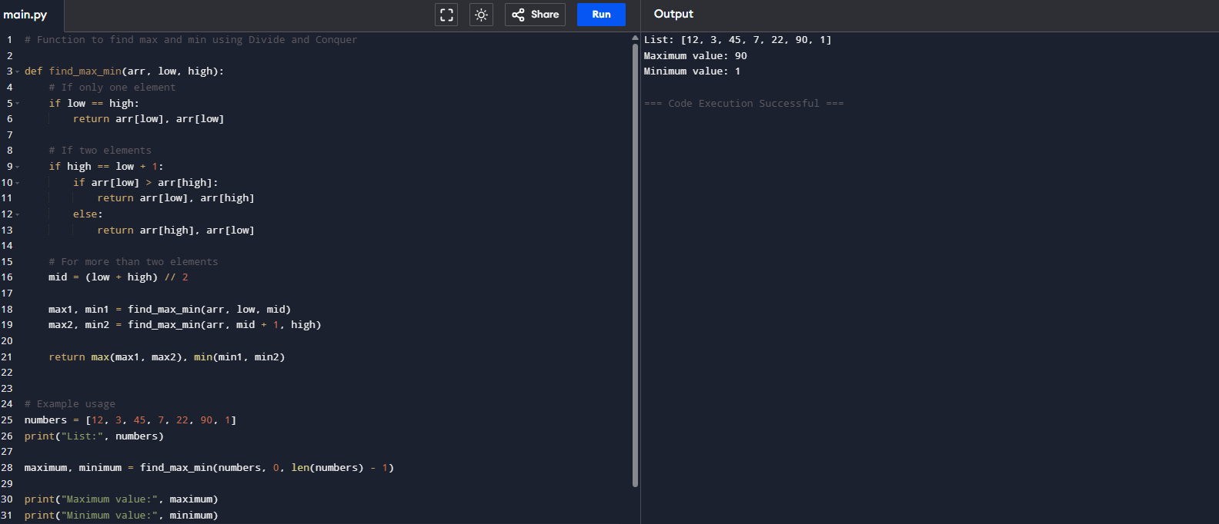
18.Write a program to generate all the prime numbers.
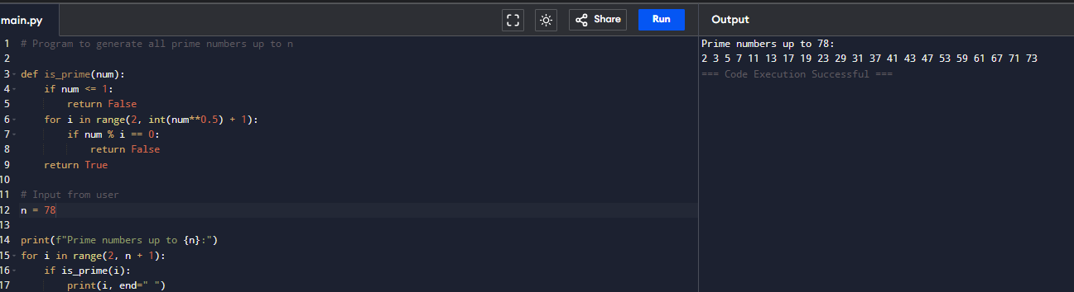
19.Write a program to perform Knapsack problem using greedy techniques.
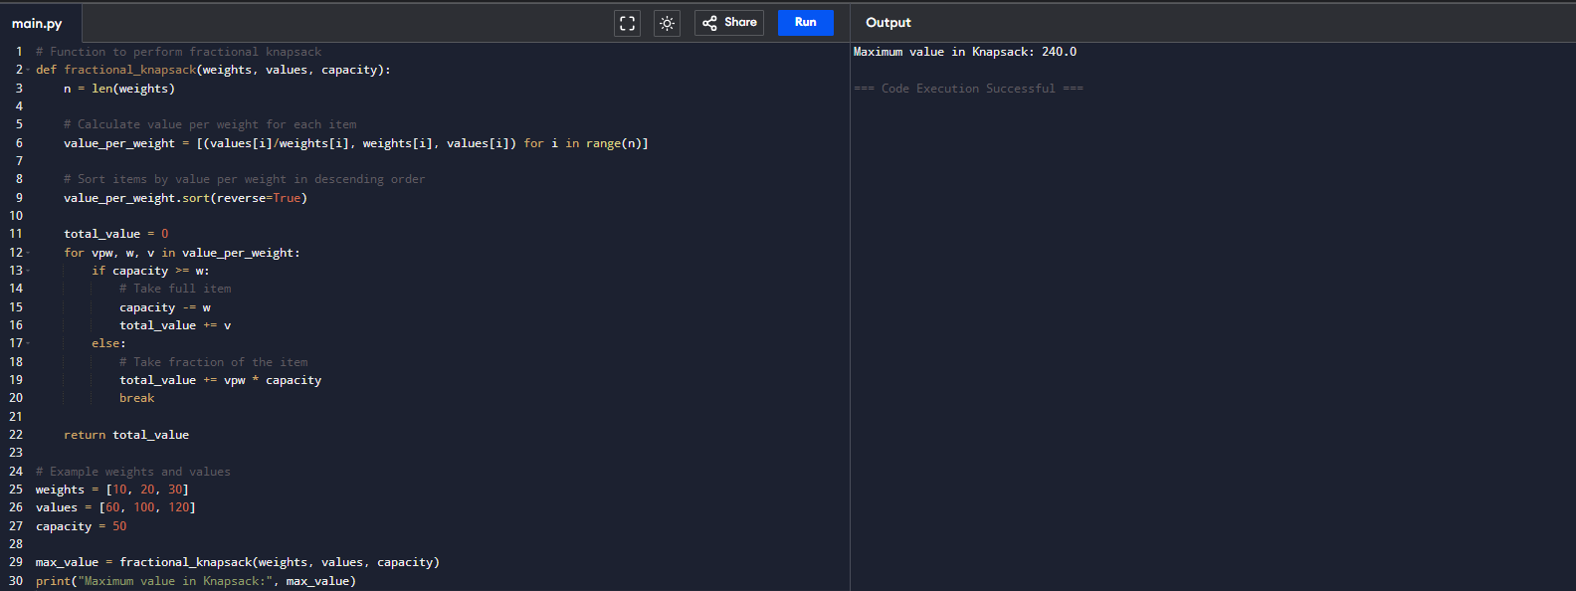
20.Write a program to perform MST using greedy techniques.
